License
Copyright (c) 2013, 2014, 2015 Olivier TARTROU
https://sourceforge.net/projects/bdm-generator/

This document is licensed under a Creative Commons Attribution-ShareAlike 4.0 International License.

All trademarks and registered trademarks are the property of their respective owners.

Features
In this procedure, we first create a working environment for Windows using STM32CubeMX. Then, the environment is ported to Linux in order to support both environments.

- STM32;
- FreeRTOS;
- Blinking LED;
- USB CDC device;
- Semihosting debug;
- BDM generic protocol.

Environment
- Board: STM32F429I-DISCO;
- STM32CubeMX: 4.9.0;
- STM32Cube: STM32CubeF4 « Firmware Package for Family STM32F4 » version 1.7.0;
- Eclipse: eclipse-cpp-mars-R-win32-x86_64;
- GNU ARM Eclipse Plug-ins;
- Make: make-3.81.exe;
- CoreUtils: coreutils-5.3.0.exe;
- GCC embedded for Windows: gcc-arm-none-eabi-4_9-2014q4-20141203-win32.exe;
  - Includes GDB and other GNU tools;
- OpenOCD: openocd-0.8.0.7z;
- Zadig (USB installer): zadig_2.1.1.exe;
- Virtual Com Port driver: stsw-stm32102.zip.

Follow the procedure http://kfrancois.com/2014/10/07/stm32f4-ide-using-eclipse-openocd-and-gcc-windows/ to install:
- OpenOCD;
- Make;
- CoreUtils;
- Zadig;
- GCC embedded.

STM32Cube generated code
- Install STM32CubeMX;
- Launch STM32CubeMX;
- File / New Project…
  - Board Selector / STMicroelectronics / Discovery / STM32F4 / STM32F429I-DISCO;
  - Initialize all IP with their default Mode: not checked;
- Peripherals / USB_OTG_HS / Internal Phy: Device_only;
- Peripherals/USB_OTG_HS/Activate_VBUS: check;
- PA4: Reset_State;
- MiddleWares/USB_DEVICE/Class For HS IP: Communication Device Class (Virtual Com Port);
- MiddleWares/FreeRTOS: Enabled;
- Project / Settings…
  - Set name and location (BDM);
  - Toolchain / IDE: SW4STM32;
- Save project;
- Generate source code based on user settings.

Eclipse configuration
- Extract;
- Launch;
- Create new workspace;
- Help / Install new software…
  - Install new repository: http://gnuarmeclipse.sourceforge.net/updates;
  - Install “GNU ARM C/C++ Cross Development Tools”.

Cross ARM GCC project
- File / New / C Project;
- STM32F4xx C/C++ Project / Cross ARM GCC;
- Set project name (BDM);
- Fill-in the following forms:
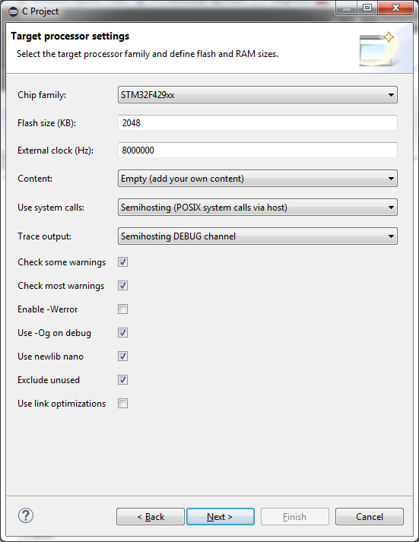

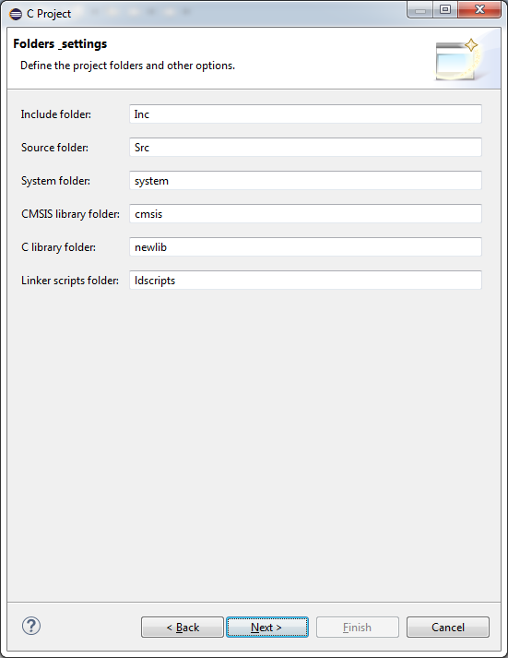

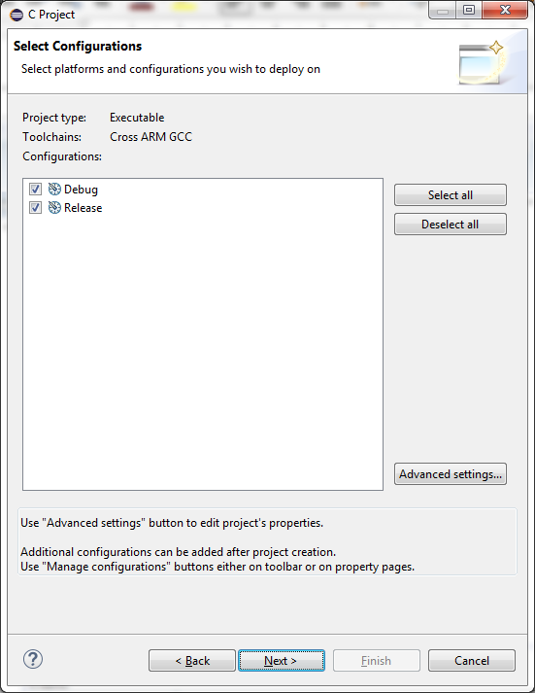

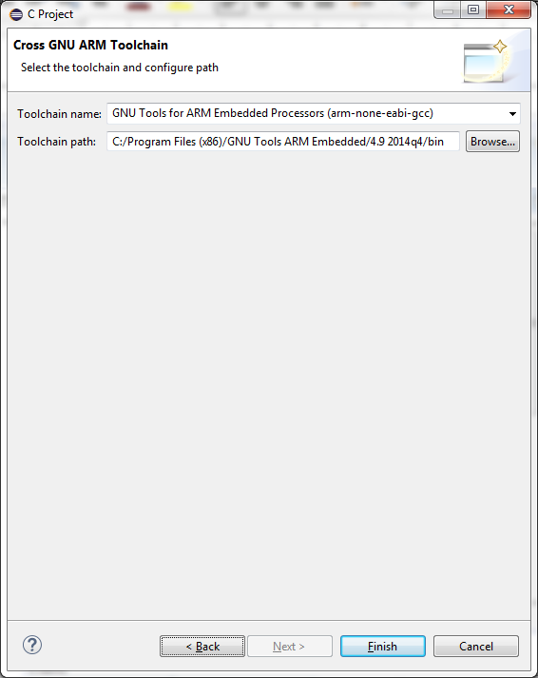

Setup target processor:
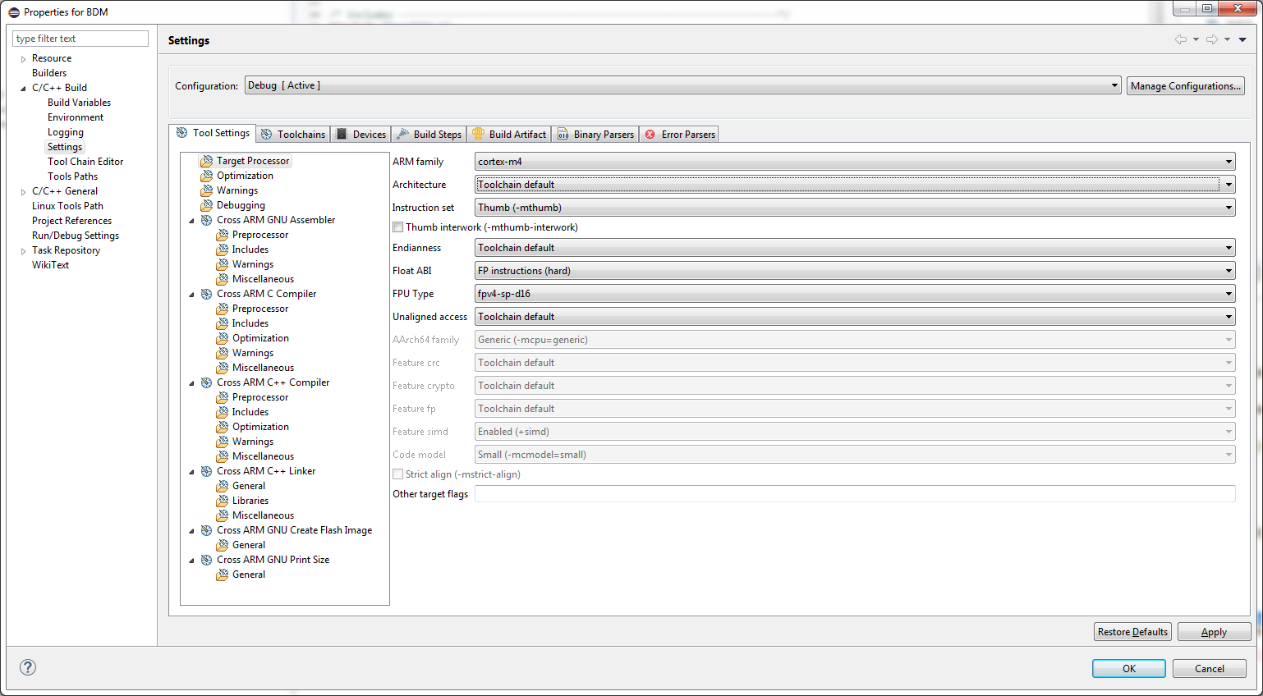
Set FPU Type to fpv4-sp-d16.

Documentation:
http://stackoverflow.com/questions/19464556/how-to-link-gcc-options-to-the-arm-mcu-fpu-datasheet

- Build the project to verify it builds without errors;
- Clean the project;
- Close the project;
- Save the project for later reference.

STM32Cube project
- In the still closed Cross ARM GCC project, delete the following folders:
  - Debug;
  - Inc;
  - Src;
  - system;
- Thus, in the still closed Cross ARM GCC project, only keep:
  - .cproject;
  - .project;
  - .settings;
  - ldscripts;
- From the generated STM32Cube code, copy:
  - Drivers;
  - Inc;
  - Middlewares;
  - Src;
- Thus, from the generated STM32Cube code, ignore:
  - .mxproject;
  - BDM.ioc;
  - SW4STM32;
- Create a GNU directory: (verify again)
  - Create folder inc:
    - Copy file \system\Inc\cmsis\cmsis_device.h from Cross ARM GCC project;
    - Copy folder \system\Inc\arm from Cross ARM GCC project;
    - Copy folder \system\Inc\diag from Cross ARM GCC project;
  - Create folder src:
    - Copy folder '\system\Src\diag' from Cross ARM GCC project;
    - Copy folder '\system\Src\newlib from Cross ARM GCC project;
- Create a folder 'OpenOCD':
  - Copy openocd.cfg;
- Back in Eclipse, open the project;
- Refresh the project;
- Add the following Assembler includes:
  - (none needed);
- Add the following C includes:
  - "${workspace_loc:/${ProjName}/Drivers/CMSIS/Device/ST/STM32F4xx/Include}"
  - "${workspace_loc:/${ProjName}/Drivers/CMSIS/Include}"
  - "${workspace_loc:/${ProjName}/Drivers/STM32F4xx_HAL_Driver/Inc}"
  - "${workspace_loc:/${ProjName}/Drivers/STM32F4xx_HAL_Driver/Inc/Legacy}"
  - "${workspace_loc:/${ProjName}/GNU/inc}"
  - "${workspace_loc:/${ProjName}/Inc}"
  - "${workspace_loc:/${ProjName}/Middlewares/ST/STM32_USB_Device_Library/Class/CDC/Inc}"
  - "${workspace_loc:/${ProjName}/Middlewares/ST/STM32_USB_Device_Library/Core/Inc}"
  - "${workspace_loc:/${ProjName}/Middlewares/Third_Party/FreeRTOS/Source/CMSIS_RTOS}"
  - "${workspace_loc:/${ProjName}/Middlewares/Third_Party/FreeRTOS/Source/include}"
  - "${workspace_loc:/${ProjName}/Middlewares/Third_Party/FreeRTOS/Source/portable/GCC/ARM_CM4F}"
- Add the following C++ include:
  - "${workspace_loc:/${ProjName}/GNU/inc}"
- Include useful resources to build;
- Exclude the following files/folders from build:
  - /Drivers/CMSIS/DSP_Lib;
  - /Middlewares/Third_Party/FreeRTOS/Source/portable/MemMang/heap_1.c;
  - /Middlewares/Third_Party/FreeRTOS/Source/portable/MemMang/heap_2.c;
  - /Middlewares/Third_Party/FreeRTOS/Source/portable/MemMang/heap_3.c;
  - /Middlewares/Third_Party/FreeRTOS/Source/portable/MemMang/heap_5.c;
  - /Middlewares/ST/STM32_USB_Device_Library/Class/CDC/Src/usbd_cdc_if_
template.c
  - /Middlewares/ST/STM32_USB_Device_Library/Core/Src/usbd_conf_template.c;
  - /Drivers/STM32F4xx_HAL_Driver/Src/stm32f4xx_hal_msp_template.c;
  - /BDM/GNU/src/newlib/_startup.c;
- Keep: /Middlewares/Third_Party/FreeRTOS/Source/portable/MemMang/heap_4.c;
- Rename startup_stm32f429xx.s to startup_stm32f429xx.S in /BDM/Drivers/CMSIS/Device/ST/STM32F4xx/Source/Templates/gcc/startup_stm32f429xx.S;
- Index / Rebuild;
- Clean / Build;

TODO: checklicences in GNU folder + remaining files from GNU project...

Correct compilation problems
- “undefined reference to `_init'”:
  - In /BDM/Drivers/CMSIS/Device/ST/STM32F4xx/Source/Templates/gcc/startup_stm32f429xx.S, comment out line “bl __libc_init_array”;
- fatal error: multiple definition of `assert_failed':
  - In project settings, undefine USE_FULL_ASSERT;
  - 3 times!!!
- warning: cannot find entry symbol _start:
  - In /BDM/ldscripts/sections.ld, replace “ENTRY(_start)” by “ENTRY(Reset_Handler)”.

Identify used libraries

Debug
- File / New / Project… / General / Project;
- OpenOCD;
- Extract archive openocd-0.8.0.7z in the project folder;
- Refresh the project;
- Run / External Tools / External Tools Configurations…
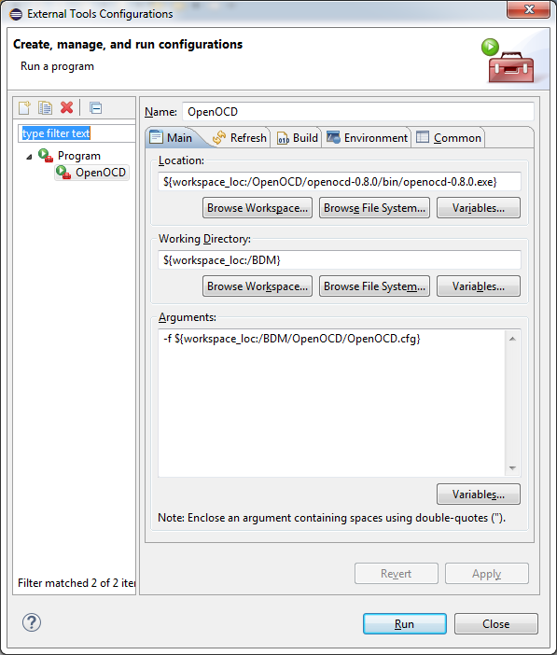
Run / Debug Configurations…

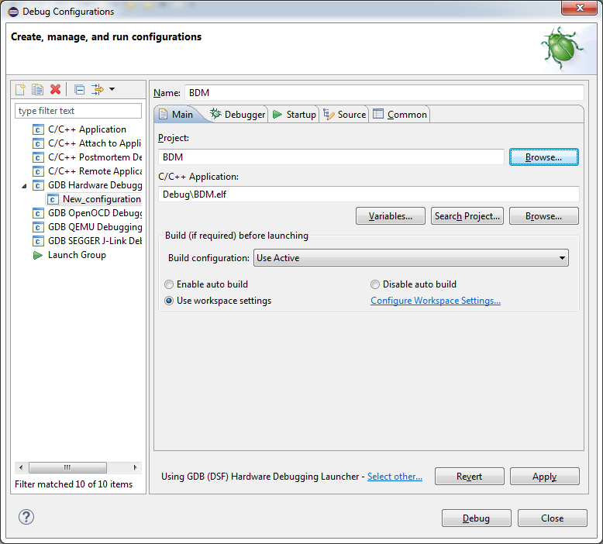

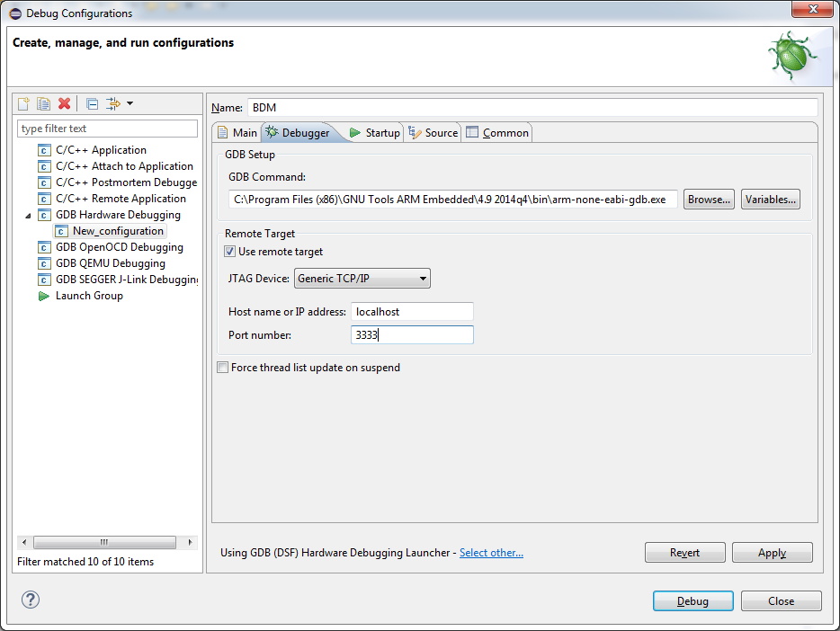
1)
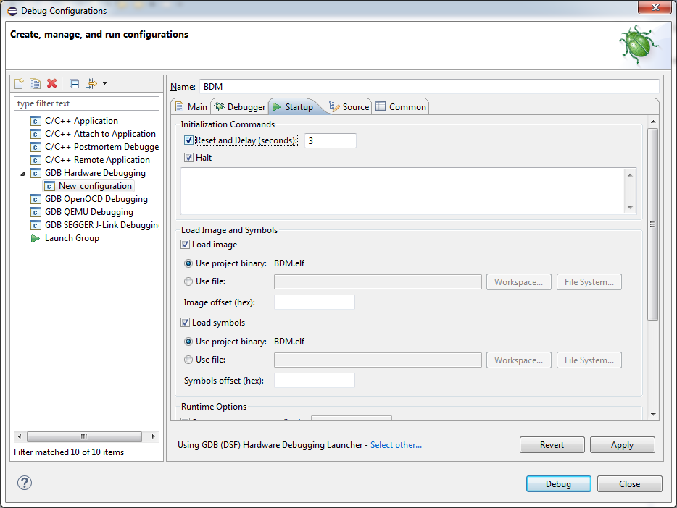

2)
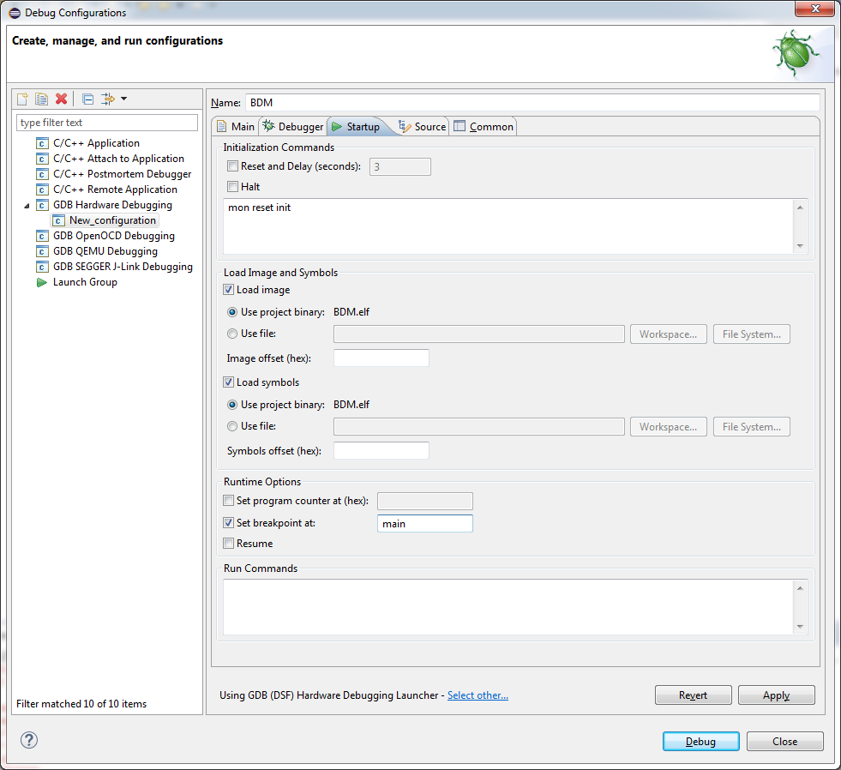
Enable semihosting printf() channel
To enable semihosting,
- add the following phrases in bold to OpenOCD.cfg:
«
source [find interface/stlink-v2.cfg]
source [find target/stm32f4x_stlink.cfg]
init
arm semihosting enable
reset_config srst_only srst_nogate
»
- Declare and call initialise_monitor_handles() in main():
extern void initialise_monitor_handles(void);

int main(void)
{
initialise_monitor_handles();
/* USER CODE END 1 */
…
}

USB setup
- Install 'driver' from ST Microelectronics;
- In 'Program Files (x86)', run the relevant 'dpinst_XXX.exe' program that will do the actual installation.

Linux
Follow the procedure http://kfrancois.com/2014/10/07/stm32f4-ide-using-eclipse-openocd-and-gcc-windows/ to install:
- OpenOCD;
- Make;
- CoreUtils;
- Zadig;
- GCC embedded.

Eclipse configuration (Linux)
- Extract;
- Launch;
- Create new workspace;
- Help / Install new software…
  - Install new repository: http://gnuarmeclipse.sourceforge.net/updates;
  - Install “GNU ARM C/C++ Cross Development Tools”;
- Close Eclipse;
- Copy BDM project to Workspace (from );
- Delete 'Debug' folder;
- Open Eclipse;
- File / Import… / General / Existing Projects into Workspace;
- tar jxfv gcc-arm-none-eabi-4_9-2015q2-20150609-linux.tar.bz2
- sudo mv gcc-arm-none-eabi-4_9-2015q2 /opt/
- export "PATH=/opt/gcc-arm-none-eabi-4_9-2015q2/bin/:/usr/local/sbin:/usr/local/bin:/usr/sbin:/usr/bin:/sbin:/bin:/usr/games:/usr/local/games"
- run Eclipse in this path;
- In /BDM/Middlewares/ST/STM32_USB_Device_Library/Class/CDC/Src/usbd_cdc.c, rename:
  - #include "USBD_CDC.h"
to
  - #include "usbd_cdc.h"
- Run / External Tools / External Tools Configurations…
- Run / Debug Configurations... /

- Create BDM folder;
- Copy BDM sources (generated + not generated);
- Delete Makefile file;
- Exclude following files from build:
  - bdm_linux_receive_thread.c;
  - bdm_linux_serial_config.c;
  - bdm_linux_serial.c;
  - main.c.

